Technical Proposal
Secure AI Appointment Assistant
Prepared by: Riseup Labs


Executive Summary
Riseup Labs proposes a secure AI appointment assistant that allows patients to interact through the existing website chatbot experience and complete appointment administration tasks without calling the VA service. The assistant will support appointment booking, rescheduling and cancellation through a controlled backend integration with PracticeHub as the confirmed primary calendar system. GoHighLevel may be used only as the patient-facing website/chatbot entry point, if retained, and not as a calendar or appointment system.
The proposed solution keeps PracticeHub as the system of record for clinician diaries, appointment availability, scheduling, rescheduling and cancellations. The AI layer will not directly access medical notes or clinical records. All AI-driven actions will pass through a secure middleware layer that validates the patient request, applies PracticeHub appointment rules, calls approved APIs only, and stores an audit trail for traceability.
Two implementation options are provided: an API-based AI model using OpenAI or a comparable enterprise AI API, and a self-hosted/local AI model. Both options follow the same security principles: data minimization, encryption in transit and at rest, protected API keys, role-based access, audit logging, prompt-injection controls and limited retention of chat data.

1. Project Understanding
Based on the meeting notes, the client is currently using PracticeHub as the diary and practice management software, including appointment management and medical notes. GoHighLevel is used for the website and current chatbot, but the existing bot mainly answers basic questions and provides booking links rather than completing booking actions inside the diary.
- Patients should be able to book appointments through a website chatbot, with appointment availability and booking actions handled in PracticeHub.
- Patients should be able to reschedule existing appointments after verification, with updates made in PracticeHub.
- Patients should be able to cancel existing appointments after verification, with cancellation actions recorded in PracticeHub.
- The solution should reduce reliance on phone-based VA support for routine appointment administration.
- The client has confirmed that PracticeHub should be used as the primary calendar system for appointment scheduling, rescheduling and cancellations. Therefore, all appointment availability checks, booking actions, rescheduling actions and cancellation actions will be handled through PracticeHub only.s
- PracticeHub has multiple clinician calendars, so the integration must handle clinician-level availability and appointment rules.
- Data security and confidentiality are critical because the practice handles sensitive patient health information.

2. Project Objectives
- Provide a secure chatbot-based appointment assistant through the patient-facing website/chatbot experience, with all calendar operations handled in PracticeHub.
- Use PracticeHub as the source of truth and primary calendar system for appointment availability, booking, rescheduling and cancellations.
- Allow AI-assisted booking, rescheduling and cancellation through approved backend actions.
- Avoid exposing medical notes, clinical history or unnecessary patient data to the AI model.
- Provide a clear technical approach comparing API-based AI and self-hosted/local AI.
- Implement strong encryption, access control, audit logging and data retention controls.

3. Proposed Scope of Work
Scope Area | Included Requirement
Website Chatbot Entry | Connect the AI assistant to the existing patient-facing website chatbot experience or a lightweight embedded web widget. Calendar actions will be handled only in PracticeHub.
Booking Flow | Collect minimum appointment information, check availability and create the appointment in PracticeHub as the primary calendar system.
Reschedule Flow | Verify appointment context, find suitable alternatives and update the PracticeHub appointment record through API-based workflow.
Cancellation Flow | Verify appointment context, confirm cancellation intent and cancel/update the appointment status in PracticeHub through API-based workflow.
Calendar Rules | Support PracticeHub clinician-level calendars, appointment types, available slots and basic booking rules provided by the practice.
Security Layer | Protect patient data using encryption, API key protection, limited data sharing, audit logs and retention controls.
Implementation Options | Document and support either OpenAI/API-based AI or self-hosted/local AI architecture.

4. High-Level Technical Approach
The solution will be designed as a secure appointment orchestration layer between the website chatbot, the AI model and PracticeHub as the confirmed primary calendar system. Instead of giving the AI model direct access to PracticeHub, the backend middleware will expose only approved PracticeHub appointment actions such as checking availability, creating appointments, rescheduling and cancelling.

4.1 Design Principles
- PracticeHub remains the primary calendar system and system of record for appointments, clinician diaries and clinical practice data.
- GoHighLevel, if retained, will be limited to the patient-facing website/chatbot entry point only. It will not be used as the calendar, diary, availability source or appointment record owner.
- The AI model is used for conversation understanding and structured intent handling, not for unrestricted system access.
- The backend middleware validates every appointment action before calling approved PracticeHub APIs for availability checks, booking, rescheduling and cancellations.
- Medical notes and clinical history are not queried, processed or modified by the AI assistant.
- All sensitive integration credentials are stored server-side only, never inside the chatbot/front-end code.

4.2 Solution Architecture - PracticeHub Primary Calendar
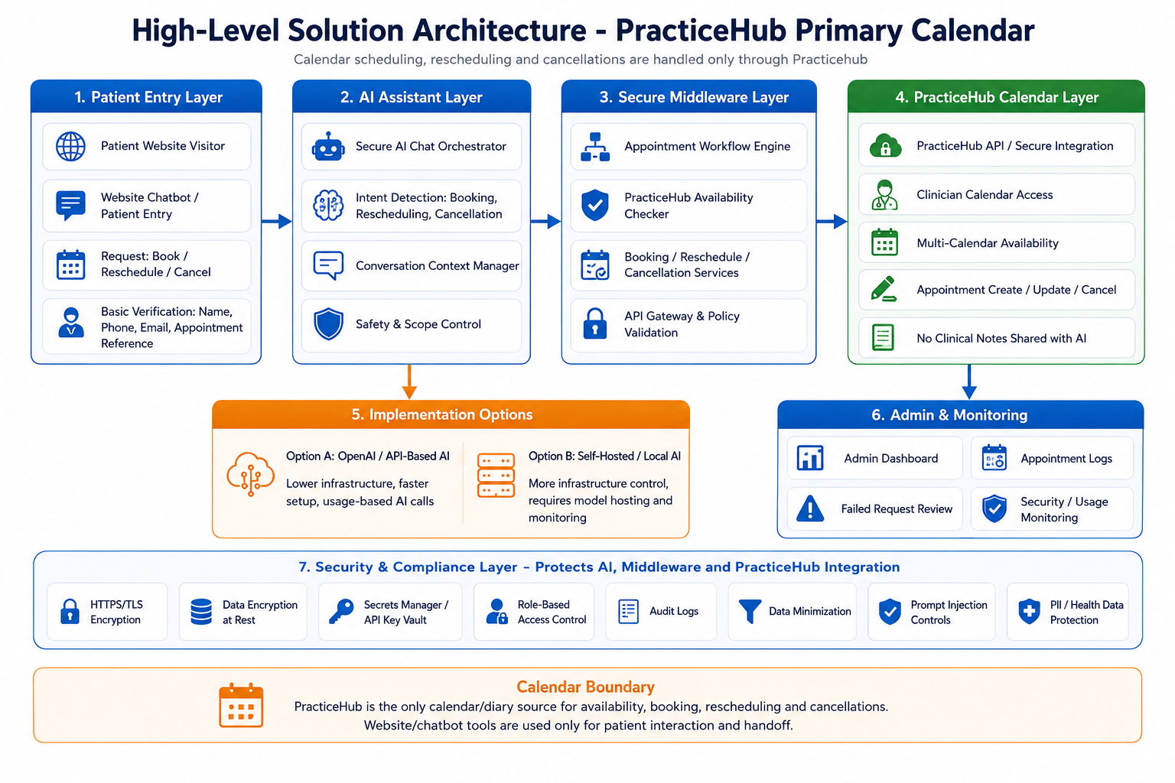
Figure 1: High-Level Solution Architecture with PracticeHub as the Primary Calendar

5. Appointment Workflow
The appointment assistant will use a structured workflow for each patient request. The AI will collect only the minimum information required to complete the task, then the middleware will perform deterministic API actions. Confirmation will be shown to the patient only after PracticeHub successfully completes the booking, reschedule or cancellation action.
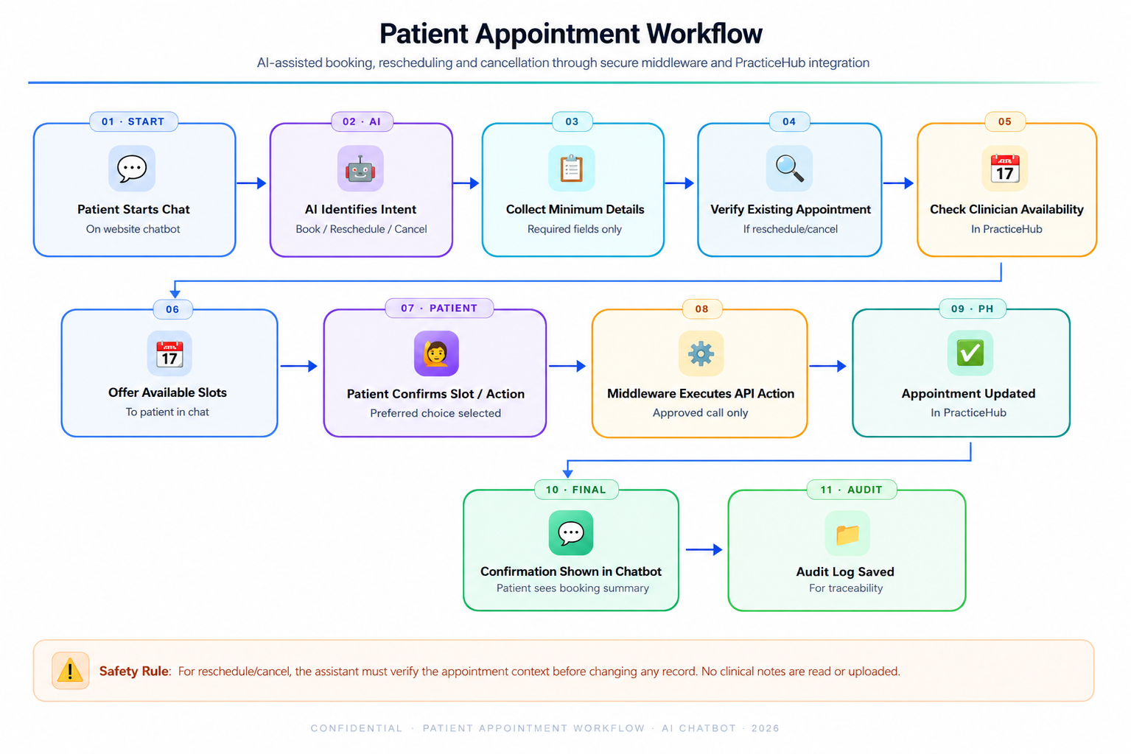
Figure 2: Patient Appointment Booking, Reschedule and Cancellation Workflow

5.1 Booking Workflow
- Patient asks to book an appointment through the website chatbot.
- Assistant identifies appointment type, preferred clinician if applicable, preferred date/time and basic contact information.
- Middleware checks available slots in PracticeHub based on configured clinician calendars and appointment rules.
- Assistant presents suitable available slots to the patient.
- After patient confirmation, middleware creates the appointment in PracticeHub and returns confirmation to the chatbot.

5.2 Reschedule Workflow
- Patient asks to move an existing appointment.
- Assistant collects appointment identifier details using minimum required verification, such as name, contact detail and appointment date/time.
- Middleware retrieves the relevant PracticeHub appointment record and checks permitted reschedule rules.
- Assistant offers alternative available slots.
- After patient confirmation, middleware updates the appointment in PracticeHub and logs the action.

5.3 Cancellation Workflow
- Patient asks to cancel an existing appointment.
- Assistant verifies the appointment context before making any change.
- Assistant asks the patient to confirm the cancellation request.
- Middleware cancels or updates the appointment status in PracticeHub through the approved API method.
- Confirmation is shown to the patient and the action is recorded in the audit log.

6. Data Security and Confidentiality Approach
The design treats patient appointment information as sensitive data. The assistant should not read or process clinical notes, treatment details or medical history. The goal is to complete appointment administration while minimizing data exposure across every component.
Security Area | Proposed Control
Data Minimization | Only appointment-related fields required for the current task will be processed. Clinical notes and medical records are excluded from AI processing.
Encryption in Transit | All chatbot, backend and API communication will use HTTPS/TLS. PracticeHub calendar API calls, any chatbot handoff calls and AI provider calls will be server-side only.
Encryption at Rest | Application database, session data, audit logs and backups will be encrypted at rest using managed database/cloud encryption or equivalent controls.
API Key Protection | PracticeHub, chatbot handoff and AI provider credentials will be stored in environment secrets or a secrets manager, with no exposure in client-side code.
Access Control | Only authorized admin/development users will have access to production systems. Role-based permissions will be applied where admin access is required.
Audit Trail | Booking, reschedule and cancellation actions will be logged with timestamp, action type, system response and masked/minimized patient reference.
AI Guardrails | The AI assistant will be restricted to appointment administration. It will not provide diagnosis, treatment advice or clinical interpretation.
Prompt Injection Controls | The middleware will enforce allowed actions independently from the model response. The AI cannot call arbitrary tools or execute unapproved operations.
Retention Control | Chat transcript storage will be minimized. Retention duration will be configurable based on the client’s data governance preference.

6.1 AI-Specific Security Controls
- Define a strict system prompt and allowed appointment intents only.
- Use structured tool/function calls for checking availability, booking, rescheduling and cancellation.
- Validate all model outputs before they reach PracticeHub appointment APIs or any required chatbot handoff layer.
- Confirm high-impact actions such as cancellation and rescheduling before execution.
- Rate-limit chatbot requests to reduce abuse and uncontrolled AI usage.
- Mask or avoid unnecessary personal information in logs and AI prompts.

7. Proposed Technical Stack
Layer | Recommended Technology / Approach
Chatbot Front End | Existing patient-facing website chatbot integration or lightweight embedded JavaScript chatbot widget.
Backend / Middleware | Python FastAPI service for secure appointment orchestration, API validation and tool-routing.
AI Layer | OpenAI API or comparable enterprise AI API with business data controls and structured tool/function calling.
Practice System Integration | PracticeHub REST API as the primary calendar integration for appointment availability, booking, rescheduling and cancellation, subject to available endpoint permissions.
CRM / Website Integration | GoHighLevel / LeadConnector API only for website-chatbot handoff or conversation continuity where required. No GoHighLevel calendar operations or calendar synchronization.
Database | PostgreSQL for configuration, minimized session records and audit logs.
Cache / Rate Limiting | Redis or equivalent lightweight cache for sessions, rate limits and temporary conversation state.
Hosting | Secure cloud environment in a UK/EU region where feasible, using Docker-based deployment.
Security | TLS/HTTPS, encrypted database/backups, secrets management, RBAC, audit logs and retention settings.

8. Development Methodology
A focused iterative delivery approach is proposed to validate the calendar integration early, reduce implementation risk and keep the scope aligned with the agreed appointment workflows.
Phase | Methodology Focus | Key Output
1. Discovery & Access Review | Confirm PracticeHub API access, appointment rules, clinician calendars, required chatbot handoff and security requirements. | Confirmed integration plan and security checklist.
2. Secure Design | Finalize data flow, AI option, retention rules, verification rules and API action boundaries. | Approved technical design and workflow specification.
3. Core Development | Build chatbot connection, middleware, AI orchestration and appointment workflow logic. | Working appointment assistant in development environment.
4. Integration & Hardening | Connect PracticeHub calendar APIs and any required chatbot handoff APIs, then apply validation, logging, encryption and prompt-injection controls. | Integrated secure workflow ready for QA.
5. QA & Deployment | Run functional, integration, security and regression tests before production deployment. | Production deployment package and handover materials.

9. Deliverables
- Finalized technical design and architecture documentation.
- Website chatbot integration or embeddable chatbot interface.
- Secure backend middleware for appointment workflow orchestration.
- PracticeHub API integration as the primary calendar system for appointment availability, booking, rescheduling and cancellation where supported by API permissions.
- GoHighLevel integration only for chatbot handoff or patient-facing conversation continuity where required; no GoHighLevel calendar synchronization is included.
- AI assistant configuration for either OpenAI/API-based model or self-hosted/local model.
- Security controls: encryption setup, API secret handling, audit logging, access controls and retention configuration.
- QA test report covering functional, integration and security test results.
- Deployment guide, environment configuration notes and handover documentation.

11. Testing and Quality Assurance
Testing Area | QA Coverage
Functional Testing | Validate booking, rescheduling and cancellation workflows for new and existing patients.
Calendar Rule Testing | Validate clinician calendars, slot availability, appointment type duration, blocked slots and double-booking rules.
Integration Testing | Verify PracticeHub calendar API calls, required chatbot handoff calls, response handling, error handling and rollback/failure messaging.
Security Testing | Verify HTTPS, server-side API keys, access control, encrypted storage, log masking and retention rules.
AI Guardrail Testing | Test non-appointment requests, clinical questions, prompt injection attempts and unauthorized action requests.
Data Privacy Testing | Confirm that clinical notes are not accessed and unnecessary patient data is not sent to the AI model.
Performance Testing | Test chatbot response time, availability lookup response and API timeout handling under expected usage.
Regression Testing | Re-test all core workflows after fixes and deployment configuration changes.

12. Assumptions and Dependencies
- The client will provide required PracticeHub API access for calendar operations and any required chatbot handoff access in a secure manner.
- The client will provide access to their current website codebase so that the chatbot integration can be done
- PracticeHub API permissions will support the required appointment actions, or an approved workaround will be confirmed during discovery.
- The client will confirm clinician calendars, appointment types, working hours, reschedule rules, and cancellation rules.
- The assistant will not access, modify, or summarize clinical notes or medical records.
- The client will confirm data retention preferences and required data processing/vendor agreements before production use.
- Existing PracticeHub notification/reminder features will be used where possible instead of building separate notification modules. GoHighLevel may support website chatbot handoff only where required, but it will not be used for calendar scheduling, rescheduling, cancellations, or calendar synchronization.

13. Out of Scope
- Replacing PracticeHub with a new full practice management or diary system.
- Using GoHighLevel, Google Calendar, or any separate calendar system for appointment availability, scheduling, rescheduling, or cancellations.
- Processing, editing, or summarizing medical notes and clinical records.
- Providing medical diagnosis, treatment advice, or clinical triage through the chatbot.
- Building a mobile app or patient portal.
- Payment processing, membership billing, or insurance workflow.
- Voice call automation or phone bot implementation.
- Large-scale CRM rebuild or custom marketing automation outside appointment chatbot workflows.

14. Conclusion
This proposal outlines a secure and practical AI appointment assistant that can help the practice reduce manual appointment handling while improving patient convenience. By integrating the website chatbot with PracticeHub as the only calendar system through a controlled workflow, the solution will support booking, rescheduling and cancellation while keeping patient data protected through encryption, access control, audit logging and data minimization. The recommended approach allows the client to compare API-based AI and self-hosted AI options and choose the most suitable model based on security, implementation speed and long-term control.

